AI for Market Trend Analysis- Report

Problem Statement:
This project aims to analyze market demand using historical order data and machine learning techniques. The dataset contains time-based features such as week of the month and day of the week, urgency-based features such as urgent and non-urgent orders, order category features (Order Type A, B, and C), and sector-wise order volumes including fiscal sector orders, traffic controller orders, and multiple banking-related order columns.
The problem addressed is to predict the total number of orders (target variable: Total Orders) using these contributing factors and to further categorize demand into meaningful levels. This helps in understanding how different order types, urgency levels, and sectors collectively influence overall market demand.

Approach:
The approach follows a structured machine learning pipeline implemented in Python using a Jupyter Notebook.
First, the dataset is loaded and explored to understand feature distributions and relationships. Missing values present in the data are handled using a forward-fill method, as implemented in the code, to maintain continuity without dropping observations.
All input features — including temporal, urgency-based, order-type, and sector-wise variables — are separated from the target variable (Total Orders). Feature scaling is applied using StandardScaler to ensure that variables with different ranges contribute evenly during model training.
Two models are implemented as part of the code:
Linear Regression, used to predict the continuous target variable Total Orders, allowing the model to learn how each feature contributes to overall demand.
Decision Tree Classifier, applied after converting total orders into Low, Medium, and High demand categories using quantile-based thresholds directly defined in the notebook.
The dataset is split into training and testing sets, and both models are trained and evaluated within the same notebook pipeline.

Key Results:
The Linear Regression model demonstrated very strong predictive performance on the test dataset. The model achieved a Mean Absolute Error (MAE) of 7.82 × 10⁻¹⁴, a Mean Squared Error (MSE) of 1.35 × 10⁻²⁶, and an R-squared (R²) score of 1.00. These results indicate a very strong relationship between the input features and the target variable (Total Orders) within the scope of the given dataset.
For demand classification, the Decision Tree model achieved an overall accuracy of 91.67%. The confusion matrix obtained from the model is shown below:
[[4 0 0]
[0 3 1]
[0 0 4]]
The confusion matrix indicates that all low-demand and high-demand instances were classified correctly. A single misclassification occurred in the medium-demand category, where one instance was predicted as high demand. This suggests that the model is highly effective at distinguishing between extreme demand levels, with minor overlap in mid-range demand scenarios.
To visually validate the regression model’s performance, an Actual vs Predicted Demand plot is presented below, illustrating the close alignment between predicted and actual total order values.

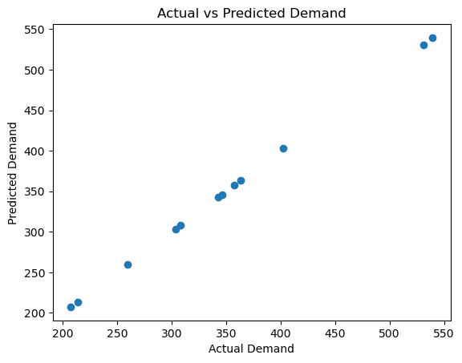

Learnings:
This project provided hands-on experience in building an end-to-end machine learning pipeline using real structured features and executable code. Key learnings include:
How temporal, urgency-based, order-type, and sector-wise variables directly influence total demand
The importance of preprocessing steps such as missing value handling and feature scaling, as implemented in the notebook
Understanding how regression and classification models behave when applied to the same dataset
Recognizing the impact of dataset size and feature composition on model performance
The project reinforced the practical application of machine learning concepts through direct implementation and analysis.

